30-04-2026
Final simulations - Updated with new param, 40% CM from 2000 – 2031, 50k popsize
Used EIR: seq (1, 20, 0.5), 24, 32, 48, 60, 80, 100
All ages
- $Low {PfPR}_{0-100}=\left[0.009 - 0.1\right]-EIR≤2$
- $Moderate {PfPR}_{0-100}=\left[0.13 - 0.34\right]-2<EIR≤8$
- $High {PfPR}_{0-100}=\left[0.36 - 0.46\right]-8<EIR≤100$
LOW: 1.0, 1.5, 2.0 – (3)

MODERATE: 2.5, 3.0, 3.5, 4.0, 4.5, 5.0, 5.5, 6.0, 6.5, 7.0, 7.5, 8.0 – (12)

HIGH: 8.5, 9.0, 9.5, 10.0, 10.5, 11.0, 11.5, 12.0, 12.5, 13.0, 13.5, 14.0, 14.5, 15.0, 15.5, 16.0, 16.5, 17.0, 17.5, 18.0, 18.5, 19.0, 19.5, 20.0, 24.0, 32.0, 48.0, 60.0, 80.0, 100.0 – (30)

Under 5-year-olds
- $Low {PfPR}_{0-5}=\left[0.003 - 0.1\right]-EIR≤5$
- $Moderate {PfPR}_{0-5}=\left[0.12 - 0.32\right]-5<EIR≤24$
- $High {PfPR}_{0-5}=\left[0.36 - 0.5\right]-24<EIR≤100$
LOW: 1.0, 1.5, 2.0, 2.5, 3.0, 3.5, 4.0, 4.5, 5.0 – (9)

MODERATE: 5.5, 6.0, 6.5, 7.0, 7.5, 8.0, 8.5, 9.0, 9.5, 10.0, 10.5, 11.0, 11.5, 12.0, 12.5, 13.0, 13.5, 14.0, 14.5, 15.0, 15.5, 16.0, 16.5, 17.0, 17.5, 18.0, 18.5, 19.0, 19.5, 20.0, 24.0 – (31)

HIGH: 32.0, 48.0, 60.0, 80.0, 100.0 – (5)

- Averaged EIRs for low, moderate, and high
- Analysis of net impact averaged over all 3 campaigns
- Pre-intervention PfPR temporal trends = 2022 PfPR (just before nets)
- Baseline pfpr for subsequent plots = malaria prevalence among non-users when no one uses nets (0% coverage)

Temporal trends
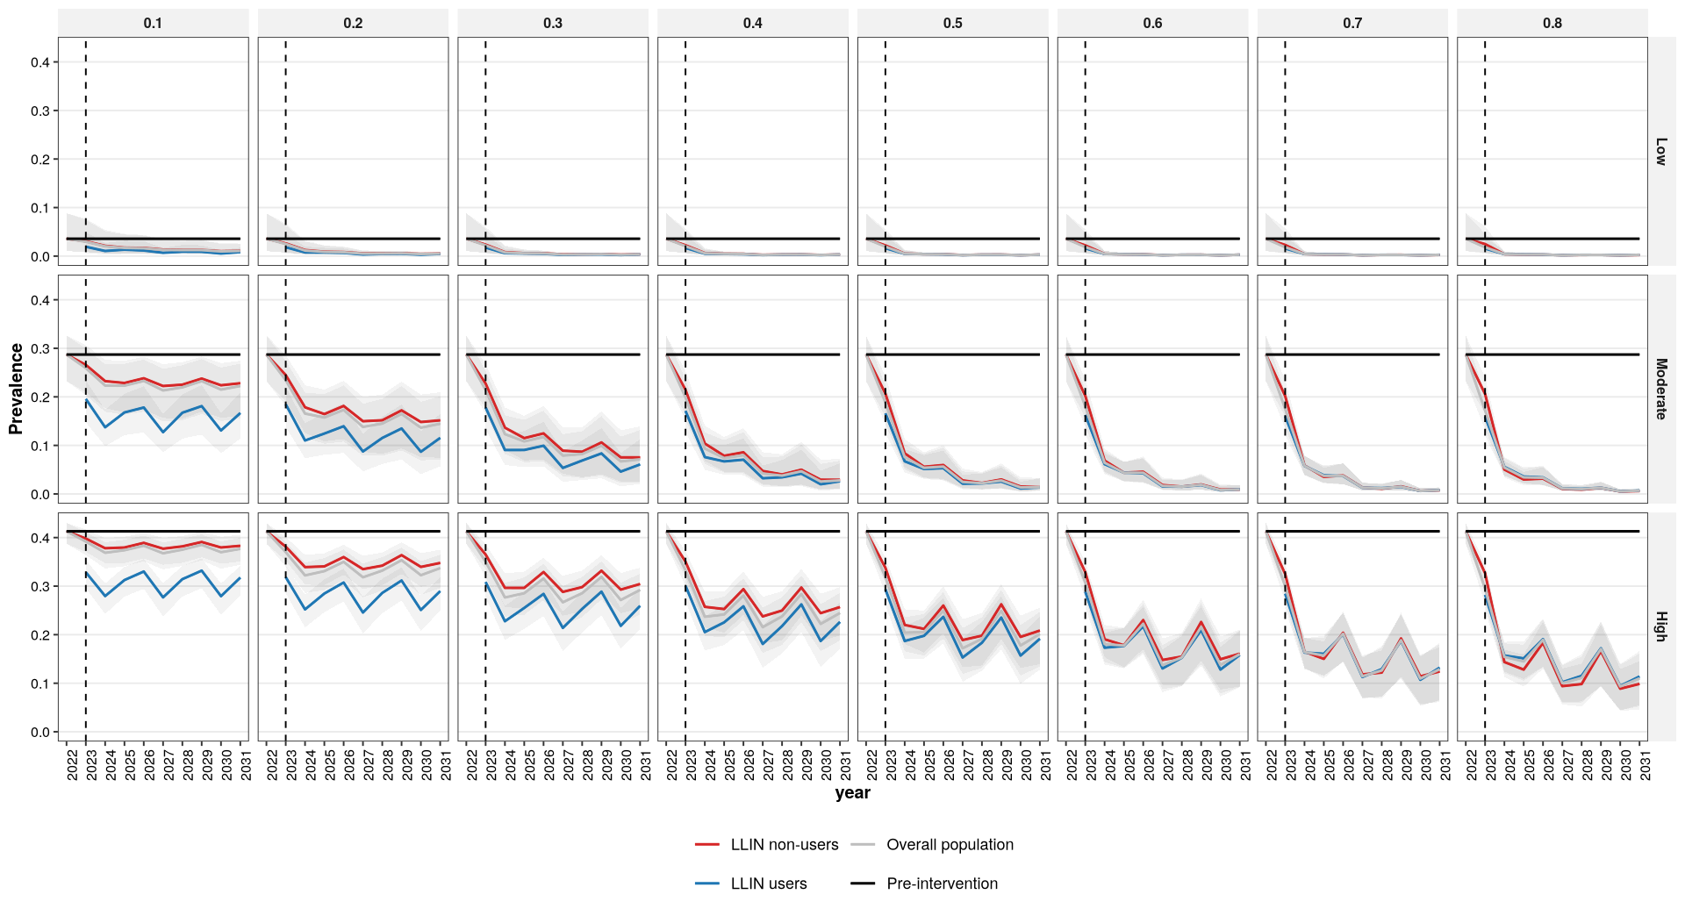
U5
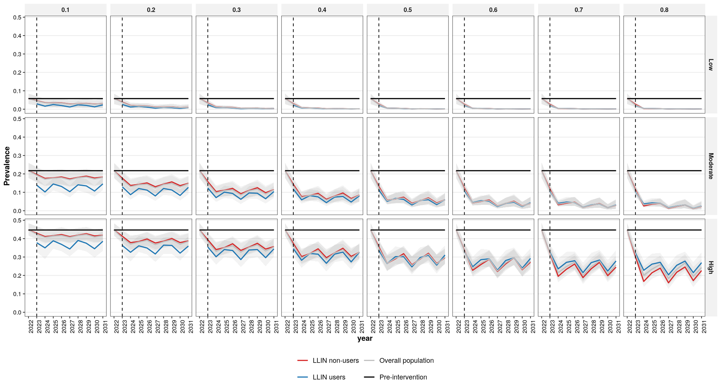

Fig 1 – drivers
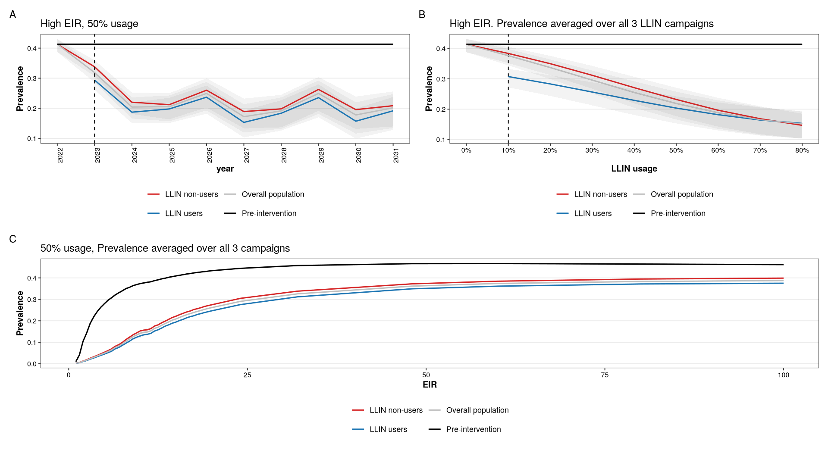

Fig 2 – All ages
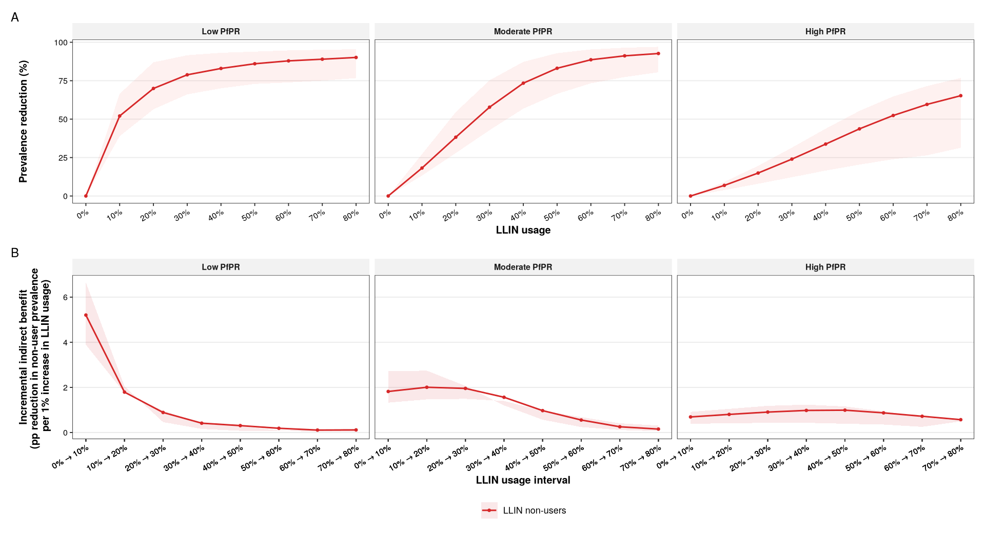
U5
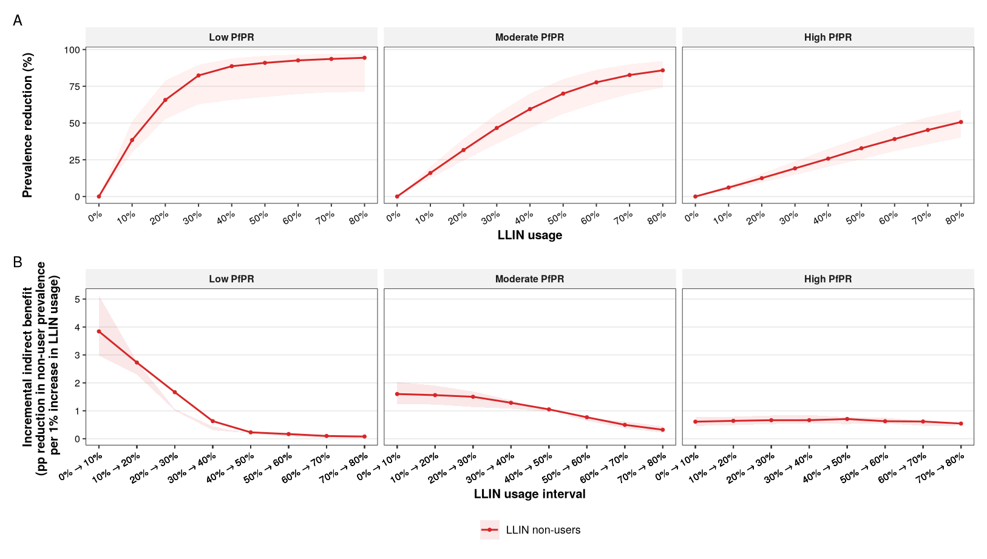

Non-users protected per additional LLIN user
Calculate the metric: $\text{Non-users protected per user}$
At a given usage level,
- $\text{number of }\text{users}\text{ = usage x population siz}\text{e}$
- $\text{remaining non-}\text{users}\text{ = (1-usage) x population size}$
- $\text{additional users}\text{ = change in usage x population size}$
- $\text{non-users protected}\text{ = change in protection x }\text{remaining non-}\text{users}$
- $\text{Non-users protected per user}\text{= }\frac{\text{non-users protected}}{\text{additional users} }$
Denominator is constant
Or can be flipped as:
$$users needed per non-user=\frac{additional users}{\text{non-users protected} }=\frac{1}{\text{non-}\text{users}\text{ protected per use} }$$

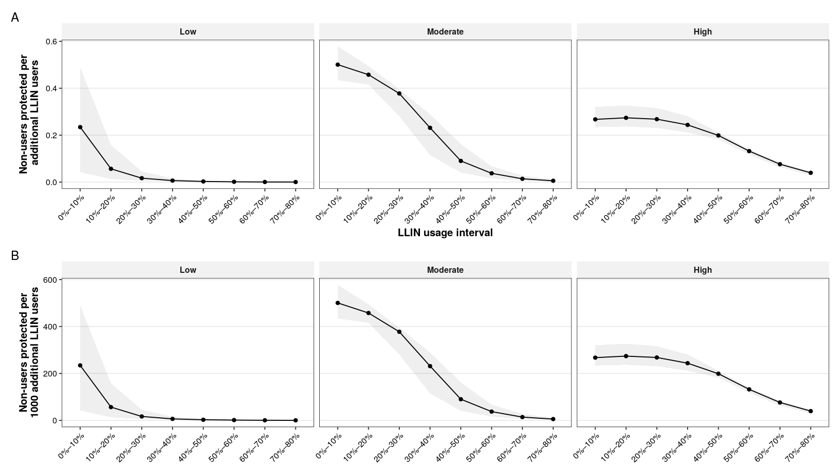
- Low: indirect protection saturates quickly. Beyond ~30% coverage, additional LLIN use yields negligible indirect benefit, making further scale-up highly inefficient.
- Moderate: indirect protection remains meaningful up to ~40–50% coverage but becomes progressively less efficient thereafter.
- High: indirect protection is sustained across a wider range of coverage levels, and additional LLIN use remains relatively efficient even at higher coverage.

Fig 3 coverage thresholds
